CatIS User Guide
  - Version 26.1
05 January 2026

Table of Contents
1 Acknowledgments 6
2 Introduction 8
3 Stakeholders of CatIS 11
3.1 Administrator of CatIS 11
3.2 Owner of Whole of Government data 12
3.3 Owner of enablers 12
3.4 Owners of institution data 13
3.5 Owners of Datasets 13
3.6 Owners of public services 14
3.7 Owners of information systems 14
3.8 Owners of data services 15
3.9 Owners of assets 15
3.10 Hosting institution of the catalogue 15
3.11 Coordinators and supervisors 16
3.12 Public users 16
3.13 External systems 16
4 WoG 18
4.1 Section: Governance 18
4.1.1 Field group: General data 18
4.1.2 Field Group: Indicators 18
4.1.3 Field Group: Strategies, policies, frameworks 18
4.1.4 Field Group: Legislation 19
4.1.5 Field Group: Coordination bodies 19
4.1.6 Field Group: Contacts 19
5 Enablers 20
5.1 Section: Enabler 20
5.1.1 Field Group: General 20
5.1.2 Links 20
5.1.3 Files 20
6 Institutions 21
6.1 Section: Institution 21
6.1.1 Field group: General Data 21
6.1.2 Field Group: Legislation 24
6.2 Field Group: Documentation 24
6.2.1 Field Group: Contact Persons 24
6.2.2 Field Group: Events and Decisions 24
6.3 Section: Secure data exchange 25
6.3.1 Field Group: Membership 25
7 Datasets 26
7.1 Definition of Dataset 26
7.2 Categories of Datasets 27
7.2.1 Authoritative (Registry) Datasets 27
7.2.2 Operational (Transactional) Datasets 27
7.2.3 Analytical and Statistical Datasets 27
7.2.4 Open Data Datasets 28
7.2.5 Reference and Classification Datasets 28
7.2.6 Derived and View Datasets 28
7.3 Levels of description 29
7.4 Structure of dataset in CatIS 29
7.5 Dataset Section 30
7.5.1 Fieldgroup: Metadata of Dataset 30
7.5.2 Field group: Documents of Dataset 30
7.5.3 Field group: Data Dictionary 30
7.5.4 Fieldgroup: Business Dictionary 31
8 Public services 33
8.1 Section: Public Service 33
8.1.1 Field group: Identification 33
8.1.2 Field group: Related Institution 36
8.1.3 Field group: Contact Persons 36
8.1.4 Field group: Related Public services 36
8.1.5 Field group: Legislation 36
8.1.6 Field group: Forms, documents 36
8.2 Section: e-service 36
8.2.1 Field group: e-service version 37
8.2.2 Field group: Prerequisite services. 38
8.3 Section: Service 38
8.3.1 Field group: Service version 38
8.3.2 Field group: Prerequisite services. 40
9 Information Systems and Registries 41
9.1 Types of systems 42
9.1.1 Registry 42
9.1.2 Information system 42
9.1.3 Subsystem of Secure data exchange 43
9.1.4 Standard Solution 44
9.1.5 New system 44
9.2 Section: Description 44
9.2.1 Field Group: General Data 44
9.2.2 Field Group: Related objects 46
9.2.3 Field Group: Contact Persons 46
9.2.4 Field Group: Tools. Standards. Protocols 47
9.2.5 Field Group: Events and Decisions 47
9.3 Section: Parameters 48
9.3.1 Field Group: SLA, security and other parameters 48
9.4 Section: Documents 49
9.4.1 Field group: Base Documents 49
9.4.2 Field group: Technical Documents 50
10 Data services 51
10.1 Section: Service 51
10.1.1 Field group: General Data 51
10.1.2 Field group: Service Level Agreements 52
10.1.3 Field group: Namespaces 52
10.1.4 Field group: Service input 53
10.1.5 Field group: Service Output 53
10.1.6 Field Group: Contact Persons 54
10.1.7 Field Group: Consumers 54
11 Data about assets 55
11.1 Section: Asset 55
11.1.1 Field group: General Data 55
11.1.2 Field Group: Contact Persons 55
11.1.3 Field group: Documents 55
11.1.4 Field Group: Events and Decisions 56
12 Registration form 57
13 Workflows 58
14 Classifications 59

Acknowledgments
The catalogue of interoperable solutions (CatIS) is a tool for getting a clear view of the IT resources in the public sector. In the catalogue, it is possible to register data:
- about Whole of Government (WoG) architecture
- about interoperability enablers
- about institutions: owners, administrators, developers and consumers of registers and information systems
- about registers and information systems
- about datasets
- about data services
- about public services
- about reusable components: semantic assets, guidelines, etc.
CatIS is a platform independent solution. It is based on the Mongo database. For implementing CatIS in a specific country, additional set up is needed. CatIS is expected to be used in two or more languages. It is recommended to use the English language interface in addition to the national language.
The target audience of this paper is the coordinating staff of information systems in the country, managers responsible for information systems and interoperable solutions. Information needed for the installation of CatIS is described in the document “CatIS. Installation and Configuration Guide”. Information needed for defining and management of application forms, data structures, and workflow process rules is described also in the document “CatIS. Administration Guide”.
It is easy to customise CatIS to the needs of a particular country and use it in a multilingual environment. This User Guide can be used as a template for drawing up an own user guide in a particular country. For implementing CatIS in your country, please contact Uuno Vallner Uuno.Vallner@ega.ee .
The International standards Dublin Core, WRC Data Catalog Vocabulary, Data Catalog Vocabulary Application Profile (DCAT-AP), ISO/IEC 11179 Metadata registry standard are considered.
CatIS should be managed by the coordination body in cooperation organisations who produce or consumer public sector data. These organisations can use additional tools for improving defining, improving data quality, monitoring and maintaining, for example:
Accurity: https://www.accurity.ai/
SelectZero: https://selectzero.io/
Dataedo: https://dataedo.com/
RIHAKE: https://koodivaramu.eesti.ee/e-gov/rihake/-/tree/main/Dokumentatsioon
For a better understanding of CatIS, it is possible to browse the public available sandbox at: https://upmind.ee/catis .

Introduction
Governance of whole of government (WoG) requires the existence information about resources: institutions, people, systems, datasets, services, semantic assets. All these objects are interdependent as depicted in Figure 1.
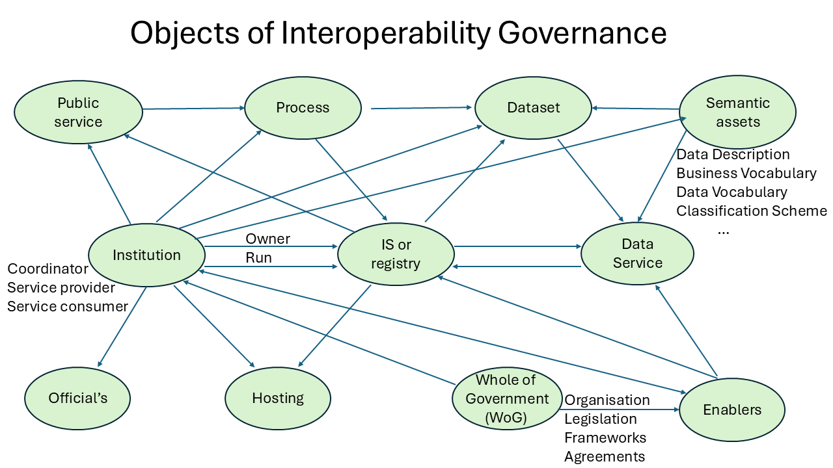
Figure 1 Objects of WoG interoperability governance

Governance decisions are implemented through objects of these repositories/catalogues.
The catalogue of interoperable solutions (CatIS) is a supplementary instrument for the coordination of state information systems, a tool for the development and administration of cross-domain systems and a support system for the maintenance of base registers and master data.
The goal of CatIS is to guarantee a transparent, optimally balanced and efficient management of public sector information systems. CatIS supports the interoperability of databases, the life-cycle management of information systems and the re-use of data by providing complete and up-to-date metadata of public sector information systems.
Catalogue objects are (some objects can be hided, if they are not needed):
- WoG. Includes information about strategies, policies, planning, legislation, organisation of governance/management of interoperability architecture
- Enablers. Includes information of enablers for achieving interoperability obligatory for all public sector institutions. Examples: eID, trust services, secure data exchange, service portal, catalogues of resources.
- Institutions. Provides data about owners, administrators, developers and consumers of registers and information systems. It includes data about important events: registration of an institution, joining the institution to the secure data exchange system, etc.
- Datasets. A dataset is a structured collection of related data, organized for analysis, processing, or machine learning, often in rows and columns like a table (CSV, Excel) but can also be unstructured (text, images, audio). Datasets are fundamental for finding insights, training AI models, and making data-driven decisions, acting as a single, manageable unit of information about a specific topic, from customer sales to scientific measurement.
- Information systems. This component provides metadata about government registries and information systems: the name of; owner; type; list of services; information about registration and approval; technical architecture; legal acts; SLA; security parameters.
- Data services. The repository ensures the interoperability of public sector information systems and the reuse of technical, organisational and semantic resources. The service repository is an addition to the metadata kept in the Database of Databases and includes specifications for all web services and a detailed description of government services (including business process descriptions). The repository describes the machine interface of services. This information is needed for establishing machine-machine data exchange.
- Public services. The repository describes human interfaces of public services. This information can be used for building citizen portals.
- Semantic assets. The repository provides information about reusable components: semantic assets, guidelines, etc.
- Business processes. Not described in documentation jet.

CatIS guarantees the transparency of the administration of the state’s information system and helps to plan the state’s information management.
CatIS provides information on the following subjects:
- Which information systems and databases are implemented in the public sector?
- What data are collected and processed and in which information systems
- Which services are provided and who use them
- Who are the responsible and authorised processors of the information systems and databases, and who the contact persons are
- On what legal basis are the databases operated, and the data processed
- Reusable components that ensure the interoperability of information systems (XML assets, classifications, dictionaries and ontologies).
CatIS serves as the procedural and administrative environment for the following actions:
- Providing clear understanding about whole of digital government: organisation, legislation, stakeholders (coordinators, supervisors, data and service providers and consumers)
- Registration of public services, reuse service descriptions in citizen and business portals
- Registration and approval of information systems and databases
- Registration of data services, supporting its reuse
- Registration connections with the secure data exchange platform
- Administration of reusable components (XML assets, classifications, dictionaries and ontologies).
CatIS provides trustworthy assistance and is a great tool for the developers, administrators and users of the state’s information system.
To implement interoperability governance with CatIS, we consider the following steps:
- Inception report. Initial model for WoG governance. Sandbox for data gathering
- Needs assessment. Initial inventory of governance processes and resources
- Customisation of models for governance WoG, Institutions, Enablers, Public Services, Registries and Information Systems, Data services, Assets
- Review of legislation of state information ecosystem and WoG enablers
- Review of procedures of governance state information ecosystem
- Training and workshops for coordination and management bodies
- Set up production environment
- Training and workshops for owners of institutions, public services, registries and information systems, enablers, data services and assets. Trainings for setting and using workflows
- Support for organising interoperability governance processes trough CatIS

Stakeholders of CatIS
CatIS is a tool for the coordinated activities of several bodies. The main stakeholders of CatIS are depicted in Figure 1.
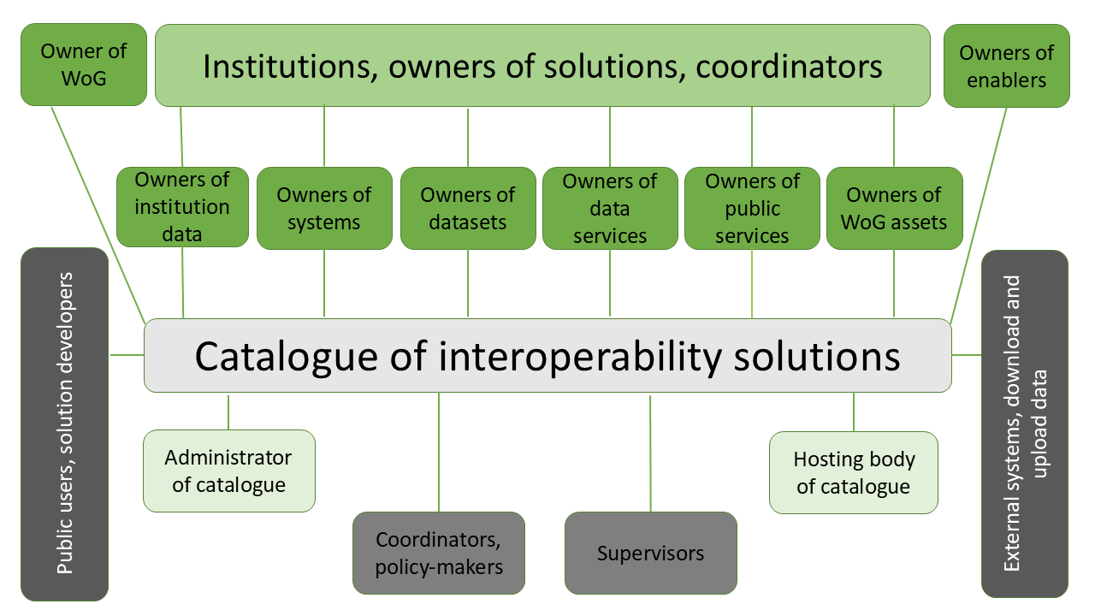
Figure 2 Main stakeholders of CatIS
Stakeholders co-create the content of the catalogue. Institution experts submit data about institutions, owners of registers data about their registers, owners of consumer organisations about their information systems, owners of services about their services, owners of interoperable assets about their assets. Coordinators and supervisors use the catalogue, and they register their decisions in the catalogue.

Administrator of CatIS
CatIS is usually owned by the e-government implementation or coordination body. The owner assigns the responsible administrators for CatIS. CatIS administrators have access to all parts of CatIS and edit rights to all objects, therefore this level of access should be granted to as few people as possible.
Only application administrators can modify forms, designate other users as application admins, edit and delete user accounts. Also, only application administrators can create new institutions and delete them.
Administrators of CatIS are usually persons coordinating information systems in this country. They can:
  - Read, list, search and download all CatIS data
  - Change all data
  - Modify forms
  - Create new institutions and delete them
  - Create workflow process and define roles used in workflows
  - Define e-mail templates
  - Define views
  - Grant rights of institution data and WoG repository administrators
  - Grant rights to other CatIS administrators
  - Edit and delete user accounts
Administrators of CatIS are responsible for the integrity and availability of CatIS.
After installing a new catalogue environment there are no users defined in the system. To add the first administrator user, navigate to the “Sign in” page and click "Sign up now". On the self-registration page, create a new user. This very first user will automatically be set as application administrator, and self-registration could be disabled from there on. After the first administrator logs in, he/she can add new users at Administration->Users and designate them as application administrators, if needed.
The “Administration Guide” contains detailed instructions for CatIS administrators.

Owner of Whole of Government data
Owners of WoG will be appointed by Administrator of CatIS. They are the representees of coordination body usually. WoG repository can have one or more administrators from coordination bodies
Administrators of WoG:
  - Can read, list, search and download public CatIS data
  - Can change the data about WoG
  - Can see all WoG an enablers data (including data with restricted access)
  - Can give rights for administrators of enablers
  - Are responsible for the completeness and updating of WoG data
A detailed description of data needed to describe WoG is specified in chapter 4.

Owner of enablers
Owners of enablers will be appointed by administrator of WoG. They are the representees of implementation body responsible for development and maintenance of enabler.
Administrators of enablers:
  - Can read, list, search and download public CatIS data
  - Can change the data about enabler
  - Are responsible for the completeness and updating of WoG data
A detailed description of data needed to describe enablers is specified in chapter 5.

Owners of institution data
An institution can start the process of joining CatIS by applying in the CatIS environment. Additionally, the official signed (may be digitally) application could be sent to the institution responsible for CatIS. The application shall contain information about the persons who have the right to represent this institution in CatIS.
After creating an entry for a new institution in the catalogue, it is possible to register new user accounts for that institution's users. Initially, the application administrator should register the first institution user and set the institution administrator role. This is done in the "User Accounts" tab of the institution page. This user can later add other user accounts and possibly mark them as institution administrators as well.
Users can be added to an institution by creating a completely new user or by assigning an existing user as this institution's user.
All users created from the institution’s "User Accounts" page are automatically linked to that institution.
Administrators of institutions:
  - Can read, list, search and download CatIS public data
  - Can change institution data
  - Can grant rights of institution administrators
  - Can grant rights for owners of registries/IS, public services, data services and assets
  - Are responsible for the completeness and updating of own institution’s data
A detailed description of data needed to describe assets is specified in chapter 6.

Owners of Datasets
Every dataset can have one or more administrators.
Administrators of public service:
  - Can read, list, search and download CatIS public data
  - Can change metadata of own dataset
  - Can see hidden data of institution
  - Are responsible for the completeness and updating of own dataset data
Administrators of datasets can self-register to CatIS; rights will be assigned by the administrator of the institution.
A detailed description of data needed to describe services are specified in chapter 7.

Owners of public services
Every public service can have one or more administrators.
Administrators of public service:
  - Can read, list, search and download CatIS public data
  - Can change metadata of own service
  - Can see hidden data of institution
  - Are responsible for the completeness and updating of own service data
Administrators of public services can self-register to CatIS; rights will be assigned by the administrator of the institution.
A detailed description of data needed to describe services are specified in chapter 8.

Owners of information systems
Every registry and information system (IS) can have one or more administrators. Owners of registries must describe the metadata of their own registries. Information systems could also have no own data. They can provide and use services by using data from base registers.
Administrators of registers or information systems:
  - Can read, list, search and download all CatIS data
  - Can change the metadata of own register/IS
  - Can see all data (including data with restricted access) of the institution
  - Are responsible for the completeness and updating of own registry/IS metadata
Administrators of register/IS can self-register to CatIS, rights will be assigned by the administrator of the institution’s metadata.
A detailed description of data needed to describe the registers/IS are specified in chapter 9.

Owners of data services
Every service can have one or more administrators. The main elements of the service description are service input and output fields, WSDL, and rules of use of service.
Administrators of services:
- Can read, list, search and download all CatIS data
- Can change metadata of own service
- Can see hidden data of the institution
- Are responsible for the completeness and updating of own service data.
Administrators of services can self-register to CatIS; rights will be assigned by the administrator of the institution.
A detailed description of metadata needed to describe services is specified in chapter 10.

Owners of assets
Every asset can have one or more administrators. Assets are classifications, code lists, dictionaries, agreed schemas, standards, rules, etc.
Administrators of assets:
  - Can read, list, search and download all CatIS public data
  - Can change data about own asset
  - Can see hidden data of institution
  - Are responsible for the completeness and updating of own asset data
Administrators of services can self-register to CatIS; rights will be assigned by the administrator of the institution.
A detailed description of metadata needed to describe assets is specified in chapter 11.

Hosting institution of the catalogue
The hosting institution is usually an implementation body, but the implementation body can outsource CatIS hosting to other institutions. The hosting institution is responsible for installation, configuration, maintenance, archiving and supporting CatIS data and software.
The “Installation and Configuration Guide” contains detailed instructions for system administrations and supporting persons.

Coordinators and supervisors
Coordinators and supervisors see all CatIS data, including data hidden from public users. They use CatIS for making decisions in the ICT domain. Usually, they have special roles in workflow processes. For example, they assess:
- Compliance of documentation of registers and information systems with the legislation
- Compliance of documentation of registers and information systems with the interoperability framework (and/or other documents)
- Fulfilment of the once-only principle
- Fulfilment of requirements of the conceptual model of e-services
- Fulfilment of privacy and security requirements
- Compliance with agreements and standards
- Whether all registers and IS are complete and up to date
- Level of security of registers and IS
Coordinators and supervisors can make suggestions for improving CatIS data structure.
It is recommended to establish concrete guidelines for all coordinators and supervisors.

Public users
Public users include developers, journalists, scientists, students, etc. Public users can read, list, search and download public data. Sensitive data are hidden from public users. Public users cannot change any data. Developers of services and developers of systems are very important groups of public users, who reuse data from other registers. Developers can find all needed information (descriptions of systems, structure and meaning of data, descriptions of services) from CatIS. There is no need for additional contacts with developers of other systems. For newcomers, CatIS data serves as examples and teaching material.

External systems
CatIS supports the first configuration of the application or migrating from one instance to another, the configurable elements of the application (forms, views, roles, workflow definitions) can be downloaded in bulk from one instance of the application and then uploaded to another. For integrating with other external systems, the application provides a REST-style API that can be used to query the data in a few different formats. All the URIs are the same, normally, for browser requests, the application responds with HTML content. If the API client specifies another format in the HTTP Accept: header, the application can respond with JSON or XML data, respectively.
The citizen portal may be most important external system. The citizen portal can reuse descriptions of public services and institutions and present this information to citizens and businesses.
These features ensure downloading data as open data. Downloaded data can be used for generating statistics, for analytics, etc.
The possibilities to organise data exchange between other solutions are described in chapters 9 and 10 of the “Administration Guide”.

WoG
The WoG catalogue includes information about strategies, policies, planning, legislation, institutional arrangements, organisational structures, roles and responsibilities, frameworks and other aspects of ensuring and monitoring interoperability at national level. Owner of WoG catalogue will be appointed by administration of CatIS.
This data description can be used as a template for drawing up an own user guide in a particular country. CatIS administrator can change or delete any element (except for “Country name”) on the WoG form. CatIS administrator can also add any elements into the form.
Fixed field:
Country name. Required field. Official name of country or place

Section: Governance

Field group: General data
Repeating: 1
CC. Country/place code by ISO 3166
Area. Location area. Example: South Asia
Population. Population in millions
GDP. GDP per capita and ranking. Example: $9,410 (126th)
Area (size). Total area in square kilometres (km²) Example: 148 460
Capital.
Language. Official language(s)
Government. Overview of Government and Politics

Field Group: Indicators
Repeating: no limit
Name. Name of indicator. Example: The UN e-Government Development Index 2020
Value. Value of indicator
Place in index. Place. Example: 179

Field Group: Strategies, policies, frameworks
Repeating: no limit
Name. Name of strategies, policies, frameworks. Example: National Strategy for Digitalisation 2022–2026
URL. Link to the document location
File. Link to the file
Responsible. Link to the responsible Institution
Description. Summary of document

Field Group: Legislation
Repeating: no limit
Legal act. Name of legal act
URL. Link to the document
Abstract. Summary of legal act

Field Group: Coordination bodies
Repeating: no limit
Institution. Choose from the Institution list
Unit. Specify unit if needed
Description. Role and functions of coordination body

Field Group: Contacts
Repeating: no limit
Name. Name of coordinator or supervisor
Institution. Choose from list
Responsibility. Role of WoG coordinator. Example: CIO
Description. Role and functions
Email. Official e-mail
Phone. Phone number

Enablers
Repository includes information of enablers for achieving interoperability obligatory for all public sector institutions. Examples: eID, trust services, secure data exchange, service portal, catalogues of resources.
Owners of enablers appointed by owners of WoG
This data description can be used as a template for drawing up an own user guide in a particular country. CatIS administrator can change or delete any element (except for “Name”) on the enabler form. CatIS administrator can also add any elements into the form.
Fixed field:
Name. Required field. Name of enabler

Section: Enabler

Field Group: General
No repeating.
Description. In glance description
Responsible. Responsible institution

Links
Repeating. List of sources available from the Internet
Title. Name of linked source
URL. Source URL

Files
Repeating. List of files accessible inside CatIS
Title. Name of source document
File. Internal link

Institutions
The Institutions section collects data about owners, administrators, developers and consumers of registers and information systems. It includes data about important events: registration of an institution, joining the institution to the secure data exchange system, etc.
The institution can start the process of joining CatIS by submitting an application in the CatIS environment. Additionally, the official signed (may be digitally) application could be sent to the owner of CatIS. The application shall contain information about persons who have the right to represent this institution in CatIS.
After creating an entry for a new institution in the catalogue, it is possible to register new user accounts for that institution's users. Initially, the application administrator should register the first institution user and set the institution administrator’s role. This is done in the "User Accounts" tab of the institution page. This user can later add other user accounts and possibly mark them as institution administrators as well.
When a new institution has been created in the catalogue, it is then possible to register new user accounts for that institution's users. When the application administrator registers a new institution (either via a registration request or directly), the first user for that institution should also be registered (or he/she could already be self-registered) and assigned to this institution as institution's administrator / responsible user. This is done in the "User Accounts" tab of the institution page. This user can later add other user accounts and possibly mark them as institution administrators as well.
This description has been drawn up based on the experience of Estonia and other countries. Application administrators can change or delete any element (except for “Name” and “Identifier”) on the institution form. CatIS administrator can also add any elements to the form. The elements “Name” and “Identifier” are mandatory to use.
Fixed fields:
Name. Name of institution. Fixed element. Example: Test Institution
Identifier. Short name or code of institution. Fixed element. Example: eGA
Parent Institution. If the described institution is a subordinate of another institution, indicate the parent institution. Chosen from list

Section: Institution

Field group: General Data
No repeating.
Name in English. Not required. Example: e-Governance Infrastructure Implementation Agency

Registry Code. Official code of institution given by the government. Not required. Example: 90007000
Description. Description of institution: main functions and tasks provided for the government and society, area of government, structure.
Example:
Provision health related cash and non-cash benefits, redistribution of social well-fare budget by provision of following services:
  - Compensation of medicines (non-cash benefit),
  - Supplementary cash-benefit for medications.
Structure of institution:
  - Medicines department – responsible for economics and construction of the medication related services, execution of medicines compensation services.
  - Customer service department – responsible for execution of supplementary cash-benefit for medication service.
Type. Type of organisation. Classifier lookup key. Required field.
Example: typeofinstitution
Template of options in classification:
  - Central government,
  - State institution,
  - Public body,
  - Local government,
  - Local government body,
  - Private body,
  - NGO,
  - Other. Please name:
Role. Role of institution. Checkbox options: Coordinator, Service provider, Service consumer, Solution developer, Asset owner, Standard solution owner, Other. Required field.
Address. Markdown. Optional. Location of the institution, post office box and telephone number.
URL. Optional. Link to the institution’s official website. Not required.
Business Hours. Markdown. Optional. The opening hours of the public offices that deliver services.
Thematic Area. Classifier (or checkbox). Template options:
  - Health and care
  - Pensions, social services and allowances
  - Work and labour relations
  - Doing business
  - Licenses, certificates, permits
  - Disabled people
  - Health
  - Citizenship
  - Traffic
  - Education and research
  - Consumer protection
  - Tax
  - Money and property
  - Legal advice
  - Culture and leisure
  - Housing and environment
  - Security and defence
  - Other, please name:
Example: Activity sector e.g. health, family, etc.
Business events. Classifier (or checkbox). Business events for which a company could contact that institution. Example: event will be chosen from classifier “businessEvents”.
Life events. Classifier (or checkbox). Life events for which a citizen could contact that institution. Example: will be chosen from classifier “lifeEvents”
Channel. Markdown. List the channels through which this institution is accessed (e.g. online, telephone, visit the office, etc.) and for each channel provide contact information (owner, phone number, etc).
Status. Status of institution in CatIS. For joining CatIS as an institution, there is a need to fulfil certain requirements and get approval from the coordinating body. Institutions start the joining process by submitting an application. Results of the approval process are registered in the “Events and Decisions” field group (see section 6.2.2). Checkbox options: Application, Member, Terminated. Not required.
Affiliated structure. Unlimited. Markdown.

Field Group: Legislation
Repeating: unlimited.
Name. Name of regulation
URL. Link to the regulation
Comments. Type of legislation, comments.

Field Group: Documentation
Repeating: unlimited
Any documents that can be used to inquire about the institution (Statutes, government decree and others)
Name. Name of documentation
URL. Link to the documentation
File. Link To the file
Comments. Type, comments

Field Group: Contact Persons
Repeating: unlimited
Name. Name of contact person. Example: John Smith
E-mail. Official e-mail of contact person. Example: John.Smith@eesti.ee
Phone. Official phone of contact person. Example: +372 513 9999
Function. Position and function of the contact person in the institution. Example: CIO, responsible for CatIS and X-Road.

Field Group: Events and Decisions
Repeating: unlimited
Type. Type of event. Example: Approval.
Date. Date chosen from calendar. Example: 2016-03-16
Decision. Description of decision. Example. Requirements for joining the X-Road are fulfilled.

Section: Secure data exchange

Field Group: Membership
Status. Status of joining the institution to the Secure data exchange (SDE) platform. Countries may use different solutions, for example X-Road in Estonia. For joining the SDE, the institution must fulfil certain requirements and get approval from the coordinating body. Institutions start the joining process by submitting an application. Results of the approval process are registered in the “Events and Decisions” field group.
Checkbox field: Application, Active, Terminated.
Member class. Checkbox options: GOV, COM, NGO

Datasets

Definition of Dataset
Dataset is a logically coherent, structured collection of data that is published, exchanged, or processed as a single identifiable unit for a specific purpose, such as information sharing, reuse, analysis, or service delivery. A dataset is a data product, not a system A dataset:
- SHALL have a clearly defined scope, structure, and semantics
- SHALL be identifiable by metadata, including title, description, owner, and update frequency
- MAY represent a full extract, subset, or view of data from one or more information systems or registries
- MAY be static or dynamic
- MAY be published in machine-readable form
- SHALL be governed by an identified data owner
A public sector registry is an authoritative source of one or more datasets:
- Each public sector registry SHALL provide at least one authoritative dataset corresponding to its legally defined data domain.
- Datasets derived from a registry SHALL preserve the authoritative semantics of the registry.
- Registry datasets MAY be:
  - Internal (used for interoperability between authorities)
  - External (published as open data or restricted data)
If a dataset is derived from a public sector registry, the registry SHALL remain the authoritative source, regardless of where the dataset is published or reused.
Policy Rules on Dataset Management
- Authoritativeness Rule: Only datasets originating from designated registries SHALL be considered authoritative.
- Reuse Rule. Datasets SHALL be reusable across organisational boundaries unless restricted by law.
- Duplication Rule. Identical datasets with the same semantics SHALL NOT be maintained by multiple authorities.
- Metadata Rule. All datasets SHALL be described using standard metadata models (e.g. DCAT-AP).

Categories of Datasets

Authoritative (Registry) Datasets
Authoritative Dataset is a dataset originating from a legally designated public sector registry and representing the official and legally valid facts of a defined data domain. Characteristics:
- Derived from a public sector registry
- Single source of truth
- Legally defined semantics
- Persistent and reusable
- Governed by formal change control
Policy Rules
- SHALL be reused by all information systems
- SHALL NOT be duplicated or redefined
- SHALL prevail in case of data conflicts

Operational (Transactional) Datasets
Operational Dataset is a dataset produced by an information system as a result of executing public sector business processes or services. Characteristics:
- Process-specific
- Context-bound
- May reference authoritative datasets
- Typically time-bound
Policy Rules
- SHALL reference authoritative datasets where applicable
- SHALL NOT redefine registry data
- SHALL be retained according to records management rules

Analytical and Statistical Datasets
Analytical Dataset is a dataset created for analysis, reporting, policy evaluation, or statistical purposes, often derived from multiple source datasets. Typical source Data warehouse / analytics system. Characteristics:
- Aggregated or transformed
- Non-authoritative
- Optimised for analysis
- Often anonymised or pseudonymised
Policy Rules:
- SHALL NOT be used as a source for operational decisions
- SHALL document derivation logic and sources
- SHALL ensure compliance with statistical and privacy regulations

Open Data Datasets
Open Data Dataset is a dataset published for public reuse under an open licence, without access restrictions, in machine-readable form. Characteristics:
- Publicly accessible
- May originate from any dataset category
- Subject to openness and licensing rules
- Published via open data portals
Policy Rules:
- SHALL be described using DCAT-AP metadata
- SHALL clearly indicate source and authority
- SHALL NOT compromise personal or confidential data

Reference and Classification Datasets
Reference Dataset is a dataset providing controlled vocabularies, code lists, classifications, or taxonomies used consistently across government. Characteristics:
- Stable and reusable
- Semantically controlled
- Often small but widely used
Policy Rules
- SHALL be centrally governed
- SHALL be used consistently across datasets
- SHALL be aligned with international standards where available

Derived and View Datasets
Derived Dataset is a dataset created as a subset, projection, or transformation of one or more source datasets for a specific purpose. Characteristics:
- Non-authoritative
- Purpose-specific
- May be temporary or persistent
- Fully traceable to source datasets
Policy Rules
- SHALL preserve source semantics
- SHALL declare derivation rules
- SHALL not replace authoritative datasets

Levels of description
Datasets in CatIS can be described on three levels:
- Business level. Business dictionary of data elements in human-readable form. Answers the Question: What does this mean?
- Logical level. Data dictionary. Answers the Question: How is it represented as data?
- Technical level. At the technical level, data could be described in RDF, DDT, XSD, JSON Schema, XMI, etc. The list of types is unlimited and open. Descriptions of data on the technical level can be uploaded to the catalogue directly or by giving the corresponding URL. Answers the Question: Where and how is it stored?

Structure of dataset in CatIS
In CatIS Dataset is described in Dataset Section with four fieldgroup, described in section 7.5.
- Metadata of Dataset
- Documents of Dataset
- Data Dictionary
- Business Dictionary
Additionally following Fixed Fields are used:
Belong to the Institution. Field content will be generated during in initial creating of dataset
Dataset Name. A clear, concise name for the dataset.
Identifier. Short name or code of dataset. Example: identity-document

Dataset Section

Fieldgroup: Metadata of Dataset
Description. A summary of what the dataset contains and its purpose.
Publisher. The organization or agency responsible for the dataset.
Distribution. The information system where dataset is operated.
Access. URL where the dataset can be downloaded or accessed.
API Endpoint. If available.
Themes. e.g., Health, Education, Transport.
Category. Authoritative, Operational, Analytical, Open Data, Reference, Derived
License. Open Data License, Creative Commons, or specific government license. Usage Restrictions: Any limitations on use.
Contact. Who and how to reach for questions.

Field group: Documents of Dataset
Repeating: unlimited
Type. Type of document. The list of types is unlimited and open. Base legislation, o
Name. Name of document. Example: Regulation (EU) No 910/2014 of the European Parliament and of the Council of 23 July 2014 on electronic identification and trust services for electronic transactions in the internal market and repealing Directive 1999/93/EC
Issuer. Issuer of document. Example: European Parliament
URL. Link to the document. Example: http://eur-lex.europa.eu/legal-content/EN/TXT/?uri=CELEX:32014R0910
File. Name of uploaded file

Field group: Data Dictionary
A data dictionary is a formal, authoritative repository of metadata that defines, describes, and governs the data elements used in an information system. In a public sector information system, a data dictionary:
- Provides a common and unambiguous understanding of data
- Ensures semantic interoperability across agencies and systems
- Supports legal compliance, transparency, and reuse
- Acts as a single source of truth for data definitions
Enterprise architecture perspective:
A data dictionary specifies the meaning, structure, constraints, ownership, and usage rules of data elements, independent of technical implementation.
Fieldgroup consist of unlimited repeating groups. Each group consist following fields
Element level. Use 0 for higher level
Element name. Element name in IS. Example: first-name
Type. Choose from classification. Choose “object” if an element has child elements
Description. Clear, unambiguous description of what the element represents. Example: Birth date in form YYYY-MM-DD
PII. Personally identifiable information (PII.) Binary (yes or no)
Sensitive Data. Binary (yes or no)
Master Data. Binary (yes or no)
Source. Name of dataset responsible for this piece of data.

Fieldgroup: Business Dictionary
A Business Dictionary (sometimes called a Business Glossary) is an authoritative repository of business terms and concepts that defines their meaning, scope, and usage in business language, independent of IT implementation.
The Business Dictionary explains what the business means, while the Data Dictionary explains how data represents that meaning.
From Enterprise Architecture viewpoint a Business Dictionary is a structured and governed collection of agreed business terms, concepts, and definitions that establishes a common business language across an organization or government.
A Business Dictionary:
- Eliminates ambiguity in laws, policies, and processes
- Enables semantic interoperability across agencies
- Supports policy interpretation and implementation
- Serves as the semantic foundation for:
  - Data models
  - Data dictionaries
  - APIs
  - Reporting and statistics
In whole-of-government contexts, it is more critical than technical metadata.
Fieldgroup consist of unlimited repeating groups. Each group consist following fields.
Term. Business Term. Official name
Description. Clear, non-technical definition
Synonyms. Alternative terms
Domain. Policy area (e.g. Population, Tax)
Owner. Policy body or organization
Policy. Reference to police and legislation decisions
Related. Related element/object in Data dictionary

Public services
The repository of public services describes human-oriented services. These services are available directly for end users. Public services can be provided through electronic or physical channels. Electronic public services are accessible from front-end systems. Front-end systems reuse and aggregate data services and offer these for end users in human readable form.
Public service starts with a trigger, goes through several steps and delivers an outcome towards an end user. The outcome may but does not necessarily need to be a public decision (e.g. issuing a license involves a decision; whilst communicating the results of a job search does not).
This description is not mandatory to use. It has been drawn up based on the experience of Estonia and other countries. CatIS installation administrator can change or delete any element (except fixed fields) in the form. CatIS administrator can also add any elements to the form.
Fixed Fields.
Belong to the Institution. Field content will be generated during in initial creating of public service. The institution who has competent authority will be selected from a list of institutions. This property links a Public Service to a Public Organisation, which is the responsible agent for the delivery of the Public Service. Whether the Public Organisation provides the public service directly or outsources it is not relevant. The Public Organisation that is the Competent Authority of the service is the one that is ultimately responsible for managing and providing the public service.
Service Name. Name of public service. Example: Applying for an identity document.
Identifier. Short name or code of service. Example: identity-document

Section: Public Service

Field group: Identification
Repeating: 1, hidden: no.
Icon. Icon for the service. An icon can be used for example in citizen portal. Type of field is “File”.
Description. This property represents a free text description of the Public Service. The description is likely to be the text that potential users of the Public Service see in any public service catalogue. Public administrations are encouraged to include a reasonable level of detail in the description, for instance including basic eligibility requirements for the Public Service and contact information.

Example: The ID card can be applied for at Service Offices, in foreign representations of the Republic of Estonia, or by post. The ID card can be applied for through an expedited procedure at the Service Offices. If you have not been issued the identity document earlier, it is not possible to apply for the ID card though an expedited procedure.
Status. Indicates whether a Public Service is active, inactive, under development, etc. according to a controlled vocabulary. Checkbox options: In Design, In Development, Active and Inactive, Portal. The option “Portal” means that this service will be available in the citizen portal. Example: Active, Portal.
Who can apply? The target audience for this public service. Example: Any citizen of country.
Type of Service. A public service can be provided through different channels. Checkboxes indicate all possible channels. Checkbox options: Information, Web service, Mobile App, E-mail, Form, Service Bureau, Client location. Please mark here all channels used for this public service.
Example: Information, Web service, Form, Service Bureau.
Thematic Area. Lookup key for predefined classification. This property represents the Thematic Area of a Public Service as described in a controlled vocabulary, for instance social protection, health, recreation, culture and religion, family, traveling, economic affairs, tax, staff, environment. Checkbox options: Citizenship, Culture and religion, Economic affairs, Education and research, Environment, Family, Health, Recreation, Social protection, Tax, Travelling.
Example: thematicArea
Business event. Lookup key for predefined classification. A Business Event is a specific situation or event in the lifecycle of a business that fulfils one or more needs or (legal) obligations of that business at this specific point in time. A Business Event requires a set of public services to be delivered and consumed in order for the associated business need(s) or obligation(s) to be fulfilled.
Example of classification:
  - Registering a company
  - Needing a licence, permit or certificate to start or continue an activity
  - Registering Intellectual Property
  - Registering a branch office
  - Starting a new activity
  - Financing a company
  - Hiring an employee
  - Participating in public procurement
  - Notifying and reporting to authorities
  - Having problems with paying creditors
  - Restructuring a company
  - Dissolution of a company
Example: choose appropriate events from “businessEvent” classifier
Life event. Lookup key for predefined classification. The life event represents an important event or situations in a citizen's life where public services may be required. Example of classification:
  - Having a child
  - Becoming a (social) caretaker
  - Starting education
  - Looking for a new job
  - Losing/quitting a job
  - Looking for a place to live
  - Changing relationship status
  - Driving a vehicle
  - Travelling abroad
  - Moving to/from the country
  - Going into military service
  - Facing an emergency/health problem
  - Facing a crime
  - Retirement
  - Death of a relative
Example: choose appropriate events from “lifeEvent” classifier
My Data. Lookup key for predefined classification. My Data links to services that contain sensitive data of citizen accessible for authenticated users only.
Example of classification from “personalData”:
  - Me and my family
  - Health
  - Pensions and allowances
  - Education and research
  - Traffic and vehicles
  - Real estate
  - Legality

Field group: Related Institution
Repeating: unlimited
Type of relation. Type of relation. Examples: Owner, Affiliate, Supervisor
Name. Name of the related Institution.

Field group: Contact Persons
Repeating: unlimited
Name. Name of contact persons. Example: Hanna Trump
E-mail. Official e-mail of contact person. Example: Hanna.Trump@eesti.ee
Phone. Official phone of contact person. Example: +372 513 9999
Function. Position and function of the person in the institution. Example: Head of service department, responsible for the service.

Field group: Related Public services
Repeating: unlimited
Type of relation. Choices: prerequisite, associated
Related public service. Name of public service in CatIS. Example: Application for a passport

Field group: Legislation
Repeating: unlimited
Name. Name of act
URL. URL to the text of act
File. Link to the text inside CatIS

Field group: Forms, documents
Repeating: unlimited
Name. Name of supporting document
URL. Link to the document
File. Link to the text inside CatIS

Section: e-service
This section may be repeated.

Field group: e-service version
Version activation date. Date of activation
E-service version. This field is used to match the service version description with the technical specification of the e-service in the Citizen Portal. This value must be unique among all e-service versions of this service. Editing this value later should be avoided and if it must be done, it is important to update the configuration of the service description in the Citizen Portal accordingly.
Version status. Choices: Concept, Under development, Active, Inactive
URL. Link to the service in case of e-service
Required Documents. Markdown
Example: To obtain a passport, the citizen submits:
application:
identification card, and in case of not reaching 16 years of age, a birth certificate.
In case of not reaching the age of 16, the parents' marriage, death, paternity certificates or a certificate of being a single mother or a court decision on the court's decision to be recognized as missing or dead in accordance with the law
in case of not reaching the age of 18, written agreements of the parents and the child
Other documents certifying the identity provided by the decision of the Government
Certificate of military registration or military record book
Receipt of payment of state duty.
Application Fee. If there is a fee for using the service, indicate it here.
Examples:
Purpose: Provision of biometric passport
Method of payment: Non-cash
Payment amount: 25,000 AMD
The account number of the RA state budget: 900005162160

Purpose: To provide the passport within one working day
Method of payment: Non-cash
Payment amount: 20,000 AMD
RA Police extra-budget account number: 900013159034
Purpose: To provide the passport on the 3rd working day
Method of payment: Non-cash
Payment amount: 10,000 AMD
RA Police extra-budget account number: 900013159034

Purpose: To provide the passport on the 5th working day
Method of payment: Non-cash
Payment amount: 5,000 AMD
RA Police extra-budget account number: 900013159034
Delay Time.
Example: The passport is issued on the 15th working day, or on the 1st, 3rd or 5th working day for an additional fee.
Application Process. Markdown text. Example: The person applies to the passport service or AVV. The integrity of the documents is checked on the spot by the employee and if there is no legal prohibition, the application is accepted.
The printed passport is handed over to the applicant or the person authorized by him.

Field group: Prerequisite services.
Repeating: unlimited
Prerequisite services. Choose appropriate services

Section: Service
This section may be repeated. For example, you can use separate instance of this section for manual services in each bureau. This model allows for different approaches. For example, you can use a separate section for all locations of service bureaus or describe all locations in the field “Where to Apply”.

Field group: Service version
Version activation date. Date of activation
Manual service version. This field is used to match the service version description with the technical specification of the e-service in the Citizen Portal. This value must be unique among all e-service versions of this service. Editing this value later should be avoided and if it must be done, it is important to update the configuration of the service description in the Citizen Portal accordingly.
Version status. Choices: Concept, Under development, Active, Inactive
URL. Link to the service in case of e-service
Required Documents. Markdown
Example: To obtain a passport, the citizen submits:
application:
identification card, and in case of not reaching 16 years of age, a birth certificate.
In case of not reaching the age of 16, the parents' marriage, death, paternity certificates or a certificate of being a single mother or a court decision on the court's decision to be recognized as missing or dead in accordance with the law
in case of not reaching the age of 18, written agreements of the parents and the child
Other documents certifying the identity provided by the decision of the Government
Certificate of military registration or military record book
Receipt of payment of state duty.
Fee. If there is a fee for using the service, indicate it here.
Examples:
Purpose: Provision of biometric passport
Method of payment: Non-cash
Payment amount: 25,000 AMD
The account number of the RA state budget: 900005162160

Purpose: To provide the passport within one working day
Method of payment: Non-cash
Payment amount: 20,000 AMD
RA Police extra-budget account number: 900013159034
Purpose: To provide the passport on the 3rd working day
Method of payment: Non-cash
Payment amount: 10,000 AMD
RA Police extra-budget account number: 900013159034

Purpose: To provide the passport on the 5th working day
Method of payment: Non-cash
Payment amount: 5,000 AMD
RA Police extra-budget account number: 900013159034
Delay Time.
Example: The passport is issued on the 15th working day, or on the 1st, 3rd or 5th working day for an additional fee.
Application Process. Markdown text. Example: The person applies to the passport service or AVV. The integrity of the documents is checked on the spot by the employee and if there is no legal prohibition, the application is accepted.
The printed passport is handed over to the applicant or the person authorized by him.
Form. Link to the file for getting template for application
Where to Apply? Markdown. Example: Personally, visiting the AV department

Field group: Prerequisite services.
Repeating: unlimited
Prerequisite services. Choose appropriate services

Information Systems and Registries
Information System is an organised combination of information technology, data, processes, and human resources that is established to support the execution, management, monitoring, or decision-making of public sector functions and services. Key characteristics:
- Built to support business processes
- May contain temporary, derived, or duplicated data
- Data quality is usually fit for purpose, not necessarily legally authoritative
- Can be internal to one institution
- Often changes with process or policy reforms
One important type (or part) of information system are public sector registries. Public Sector Registry is a legally established, authoritative information system that maintains, manages, and provides persistent, structured, and verified reference data on entities of public interest, and serves as the single source of truth for a defined data domain. A public sector registry:
- SHALL be established and defined by law or regulation
- SHALL contain authoritative and legally valid data
- SHALL serve as the single source of truth for its data domain
- SHALL ensure data quality, integrity, traceability, and lifecycle management
- SHALL provide controlled access to its data for reuse by other public sector information systems
- SHALL designate a data owner and data steward
The Systems section in CatIS specifies the architecture, features, hardware, software, volume indicators of information system (IS). It describes the standards used, protocols, used assets, the conceptual and the logical data model.
This description is not mandatory to use. It has been drawn up, based on the experience of Estonia and other countries. The following types of systems are distinguished: registry, information system, standard solution, X-Road subsystem.
Estonia's experience and information materials have been used in the preparation of the guide. In a specific country some types of systems (for example SDE subsystem, standard solution, etc.) may not exist.
When generating a description of a new system in CatIS, there are two options: “Create a new system” or “Join a standard solution”. The option of joining a standard solution is described in section 7.1.4.
In any case, there is a need to fill in the fields “Name” and “Identifier”. “Name” is the official name. “Identifier” is a short name of the system. In case of a SDE subsystem, the identifier shall be presented in the form: <institution registry code>-name. Example: 90007000-catis. If the new system is a standard solution you need to mark it in the checkbox field. These three fields (“Name”, “Identifier” and “Standard solution”) are predefined fields. They do no need to be described in “system” form.
Most important logical parts of systems are Datasets. As the same datasets can be used in different systems, they are described in CatIS as separate object in chapter 7.

Types of systems
There exist many types of information systems. All systems in CatIS are described with same pattern. In WoG context most important types of systems are registers, information systems and portals. System can be combining several roles. The characteristics these systems are described in table below.
Aspect | Registry | Information System | Portal
Primary role | Authoritative data | Processing & management | Access & integration
Data ownership | Master / reference data | Operational data | None
User focus | Systems & officials | Officials / processes | End users
Scope | Domain-specific | Organisation-specific | Cross-government
Interface | System-to-system | System- and human-facing | Human-facing
In CatIS the following types of systems are distinguished: Registry, Consumer (IS), Portal, Standard Solution, X-road system, Other. They ore described in following sections

Registry
From interoperability viewpoint the most important system type is Registry. Registries own authoritative datasets with SHOULD be open for all other types of systems. The registry with its authoritative datasets is established, and it is used for performing tasks prescribed in the law, legislation issued on the basis thereof or international agreements. According to the once-only principle, it is forbidden to use separate systems/datasets for the collection of the same data.
The registry may also consist of data obtained from other registries.
Before establishing a registry, changing the composition of data collected in a dataset, introduction of a dataset or termination of a dataset, the technical documentation of the registry will be described in CatIS and approved by the concerned authorities.
All data are not always public. In that case, access restrictions are established. Access restrictions are established by legal acts.
Creation of a registry and its dataset also brings along responsibility for owner of registry. Breach of the requirements arising from the relevant legal act (e.g. disclosure of restricted information, issuance of wrong information, ignoring security measures of personal information protection) may result in a monetary fine.
Registries usually act as back-end systems. In this case, end users have no direct contact with registries: they get data from registries via special front-end systems (information systems).
By SDE (X-Road) terminology, registries are “service providers”. They provide data services through their machine-machine interfaces.

Information system
An information system is an integral system of information, persons, technical resources and methods used for collection, organisation and analysis of necessary, precise and operative information and its timely delivery to the deciders.
More than one dataset can be accessed with one information system. It is possible that no database is directly connected with the information system. It may, for example, enable access to external databases.
By SDE (X-Road) terminology, information systems are “service consumers”. They provide data services through their machine-human interfaces.

Portal
A portal is a single, coherent digital entry point that provides users with integrated, role-based access to public sector information, services, and transactions delivered by multiple autonomous public authorities, while abstracting the underlying institutional, technical, and legal complexity.
In a whole-of-government (WoG) context, a portal is not just a website. It is a strategic access layer that unifies government information and services across organisational boundaries.
Typical Functions of a WoG Portal:
- Service discovery and navigation
- Secure authentication and authorization (via shared IAM)
- Transaction initiation and status tracking
- Personalised dashboards (citizen / business / official views)
- Notifications and messaging
- Redirection or orchestration to back-office systems

Subsystem of Secure data exchange
In SDE (by example X-Road), data services are provided and used via the subsystem of an institution, after having joined the SDE.
The subsystem is an information system of the SDE member or part of this system. It must be possible to handle the subsystem as a certain integral unit.
Subsystems are autonomous in terms of providing and using SDE services. The access rights of an SDE member's subsystems are independent. Access rights given to one subsystem do not affect the access rights of the member’s other subsystems. Also, services provided by a subsystem are independent of the services provided by the member’s other subsystems.
One organisation may have several information systems that can be interfaced with X-Road. Several subsystems are generated also when making several interfaces to one information system (e.g. one for the public and the other with access restriction). For example, it is possible to make one interface for processing data of the population register and another for public queries (e.g. existence of right of residence). In the first case it is possible to change data, in the second case the data are read-only.
Each institution must itself define the subsystem(s) of SDE. The institution integral information system must be considered.
Defining the subsystem(s) of X-Road should consider how the institution might best decompose its information system providing or using services for the purpose of handling them and then split into parts.
The following aspects should be considered:
- Are the systems acting on the same legal basis? For example, a database realised based on an act or regulation and the organisation’s personnel records should not belong to the same subsystem.
- Is access to the systems organised at correct security level(s)? Systems have different confidentiality levels and access restrictions. Similarly to physical security zones, restrictions should also be realised at the virtual level.
- Do the systems work based on the same technical principles (e.g. are hosted)? Systems should be realised differently depending on whether they are used on premises or outside the organisation. Granting too many permissions to external parties should be avoided.

Standard Solution
A standard solution is a software solution where the data is entered in CatIS and it can be used as a database by several authorities or persons for performing the tasks provided by law, legislation issued on the basis thereof or international agreements. Example: some municipalities are reusing the same software solution for document management.
CatIS includes the feature to define a “standard solution” instead of an organisation-specific “Information System”. It is possible to describe it in CatIS. All organisations who want to use a standard solution should choose „Add a system “, and after that „Join standard version “. After that, you can choose a standard solution suitable for the new system. In this case, parameters from the chosen Standard Solution will be copied into the new system.
When describing a standard solution, the section „joined systems” is visible. In this section, a list of Information Systems that implement this standard solution is provided.

Section: Description

Field Group: General Data
Repeating: 1
Institution. Fixed field. Owner of system. Will be chosen from the list of existing Institutions
Name. Fixed field. Name of information systems. Example: Important Registry.
Identifier. Fixed field. Short name or code of information system. Example: IR.
Standard Solution. Fixed Field. Binary
Type. Type of Information System. Standard checkbox options:
- Registry - trusted and authoritative source of information which can and should be digitally reused by other systems. Registry functions as a back-end system without direct contact with end users. End-users get data over front-end systems. Registries data are accessible over machine-machine services.
- Consumer - information system supporting business processes of administrations.
- Portal – single web-based access point intermediating public services to end-users.
- Standard solution – technical solution developed and provided by a vendor and used independently by several institutions. Example: Document Management System of several municipalities use the same product.
- X-Road subsystem - Subsystems are autonomous in terms of providing and using SDE services
- Other.
Name in English. Example: Population register. Not required.
URL. Link to the official website. Example: http://opendata.riik.ee. Not required.
Aim. Aim of IS. Example (population register in Estonia).
Collection of reliable information and granting access to personal data:
- to state and local government agencies and other natural and legal persons for the performance of public law functions imposed on such agencies or persons by law or on the basis thereof (public duties);
- for the maintenance of records on the registration of the population of Estonia;
- to legal persons and natural persons with legitimate interest for re-use of information in the population register;
- for the performance of agreements entered into under the Foreign Relations Act.
Tasks. Tasks of System. Example: The following shall be ensured upon maintaining the population register:
- protection of private life of persons
- registration of subjects of the population registry on the basis of the administrative-territorial organisation of the country;
- access of the state and local government agencies and natural and legal persons to data in the population register for the performance of public law functions assigned to such agencies or persons by law or on the basis thereof (hereinafter public duties);
- access of legal persons and natural persons with legitimate interest to data in the population register.
Description. The structure of components, their inter-relationships, and the principles of design. Interaction with external systems.
Status. Checkbox: Application, Active, Terminated, Ended.

Field Group: Related Datasets
Repeating: unlimited
Function. Type of relation. Owner or Consumer
Name. Name of the related Dataset.
Link. Internal CatIS link to the related Dataset. Example: link to the Interoperability Framework.

Field Group: Related objects
Related objects: institutions, Systems, Frameworks and Infrastructure services
Repeating: unlimited
Function. Type of relation. Example: Subsystem.
Name. Name of the related solution. Example: Interface of the population register.
Link. URL or internal CatIS link to the related solution. Example: link to the Interoperability Framework.
Example of this field group:
Function | Name | Link
Authentication | Certification Authority | http://
Digital Signing
Data Consuming | Population Registry
Data delivery | Citizen Portal

Field Group: Contact Persons
Repeating: unlimited.
Name. Name of contact persons. Example: John Smith.
E-mail. Official e-mail of contact person. Example: John.Smith@eesti.ee
Phone. Official phone of contact person. Example: +372 513 9999
Function. Position and function of the person in the institution. Example: enterprise architect, responsible for the population register.

Field Group: Tools. Standards. Protocols
Repeating: unlimited
Function. Type of tool, facility, resource used in IS. List of types is unlimited and open. Example: operating system
Name. Name of tool. Example: Ubuntu

Example of field group:
Function | Name
Operating System | Ubuntu
Database | Oracle
Language | Python
Architecture Framework | TOGAF
Standard | WSDL
Standard | WAI
Protocol | SOAP
Protocol | REST

Field Group: Events and Decisions
Repeating: unlimited

Type. Type of event. Example: Approval.
Date. Date chosen from calendar. Example: 2016-03-16
Decision. Description of decision. Example: Architecture of register approved. Procurement process can be started.
Example of field group:
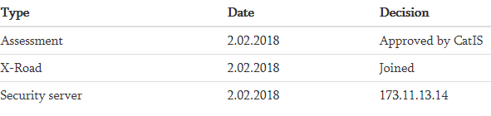

Section: Parameters

Field Group: SLA, security and other parameters
Repeating: unlimited
Parameter Name. Type of parameter used in IS for describing SLA, security level, availability, etc. List of types is unlimited and open.
Please provide information at least about the following characteristics of the solutions:
- Working hours of the solution.
- Availability of solution during working hours (%).
- Maximum number of users.
- Allowed duration of interruptions during working hours (seconds, minutes or hours).
- Applied information security methodology/process.
- Information security auditing interval (months, years).
- Security level of the solution (can be exposed in categories of availability, integrity and confidentiality).
Example:
Parameter name | Value
Information Security System | SABSA
Auditing of information security implementation | Internal audit annually. Independent/external audit after every 2 years.
Working hours | 7:00 – 23:00
Availability | 70%
Allowed duration of interruptions | 2 hours
Integrity | Data change source is detectable.
Confidentiality | All information is public
Availability | 99.9 %
Max number of simultaneous users | 200 simultaneous users
Level of information security:  Confidentiality-Integrity-Availability | C3-I2-A2

Section: Documents

Field group: Base Documents
Repeating: unlimited
Name. Name of document. Example: Regulation (EU) No 910/2014 of the European Parliament and of the Council of 23 July 2014 on electronic identification and trust services for electronic transactions in the internal market and repealing Directive 1999/93/EC
Issuer. Issuer of document. Example: European Parliament
URL. Link to the document. Example: http://eur-lex.europa.eu/legal-content/EN/TXT/?uri=CELEX:32014R0910
File. Name of uploaded file

Field group: Technical Documents
The information system documentation must express the main features, purpose and legal basis of the database to be established or changed, i.e. characteristics, which will essentially be assessed by the authority’s supervising compliance with the requirements during the subsequent approval process. The limits of subsequent establishment depend on the quality of the preparation of the technical documentation, as the database cannot have features that are not specified in the technical documentation.
The documentation includes:
- the technical description of the information system,
- the architecture document,
- the classifiers used, references to the list of classifiers or the classifiers described in the CatIS repository,
- other documents intended for sharing with others (interface instructions, service descriptions, user manuals, etc.).

Repeating: unlimited
Function. Type of function of technical document. Example: Reference architecture.
Name. Name of technical document. Example. CatIS Installation Guide.
URL. Link to the document, if it is available on the Internet.
File. Name of uploaded file in CatIS.

Data services
The repository of data services ensures the interoperability of public sector information systems and the reuse of technical, organisational and semantic resources. The service repository is an addition to the metadata kept in the Database of Databases and includes specifications for all web services and a detailed description of government services (including business process descriptions).

Here we describe data services of back-end systems. These services are not available directly for end users. These services are presented in machine-readable form. These services are accessible for front-end systems. End users can get data from front-end systems. Front-end systems can reuse and aggregate data services and offer these for end users in human readable form.

This description is not mandatory to use. It has been drawn up based on the experience of Estonia and other countries. CatIS installation administrator can change or delete any element (except “Name” and “Identifier”) on the institution form. CatIS administrator can also add any elements to the form. The elements “Name” and “Identifier” are mandatory to use.

Section: Service

Field group: General Data
Repeating: 1
Name. Name of service. Default element. Example: Personal data
Identifier. Short name or code of service. Example: rr404
Description. Service description. Example: Personal data on personal identification codes. The service returns the list of data fields about a person.
Classification. Classification of service. Checkbox options: X-Road, Open webservice, API. Example: X-Road
Personal Data: Attribute indicating whether the service includes personal data and/or sensitive data. Checkbox options: No, Yes, Sensitive. Example: Yes, Sensitive.
WSDL. Name and link to the WSDL file
Service URL. Link to the website, if available.
Rules of Use. Principles of using the service. Example: The service is open to all subjects indicated in the Law on Population Registry. A person can see the information recorded on them. Authorities can request the opening of the service through the CatIS Administrator.

Field group: Service Level Agreements
Repeating: unlimited
Parameter Name. Type of parameter used in IS for describing SLA, security level, availability, etc. List of types is unlimited and open. Example: Integrity
Value. Value of parameter. Example: T2
Example of field group:
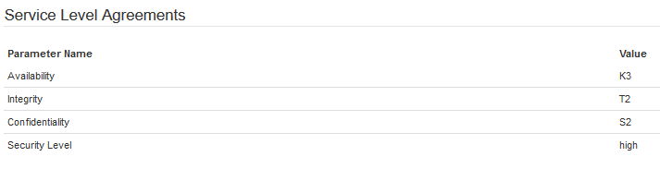

Field group: Namespaces
Repeating: unlimited
Namespace. Namespace used in service.
Example: SOAP: http://schemas.xmlsoap.org/wsdl/soap/
Example of field group:
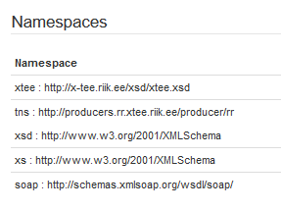

Field group: Service input
Repeating: unlimited
Level. Level of hierarchy. Example: 2.
Fieldname. Element name in IS. Example: gender
Fieldtype. Type of data element. Example: xs:string
Name: Clarification. Example: First name
Example of field group (fragment)

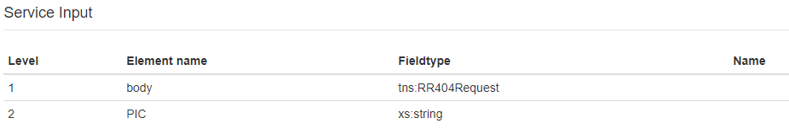

Field group: Service Output
Repeating: unlimited
Level. Level of hierarchy. Example: 3.
Fieldname. Element name in IS. Example: address
Fieldtype. Type of data element. Example: xs:string
Name: Clarification. Example: Address of person
Example of field group (fragment)

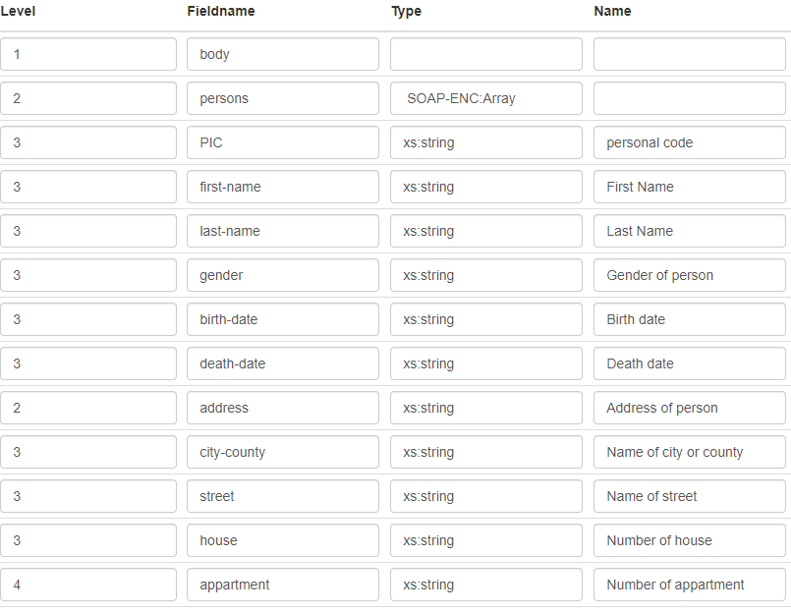

Field Group: Contact Persons
Repeating: unlimited
Name. Name of contact person. Example: Hanna Trump
E-mail. Official e-mail of contact person. Example: Hanna.Trump@eesti.ee
Phone. Official phone of contact person. Example: +372 513 9999
Function. Position and function of the person in the institution. Example: Head of service department, responsible for the service.

Field Group: Consumers
Repeating: unlimited
Name. Name of consumer organisation

Data about assets
The repository of assets gives information about reusable components: code lists, classifications, dictionaries, XML schemas, standards, enablers, semantic assets, guidelines, etc.
This description is not mandatory to use. It has been drawn up based on the experience of Estonia and other countries. CatIS installation administrator can change or delete any element (except “Name” and “Identifier”) on the institution form. CatIS administrator can also add any elements to the form. The elements “Name” and “Identifier” are mandatory to use.

Section: Asset

Field group: General Data
Repeating: 1
Name. Name of asset. Example: Interoperability framework
Identifier. Short name or code of service. Example: IF.
Owner. Responsible for asset. Example: European Commission
State of Asset. Checkbox options: Planned, Registered, Valid, Retired
Regularity of Update. Rules of updating
Valid from. Date chosen from calendar
Description. Description of asset

Field Group: Contact Persons
Repeating: unlimited
Name. Name of contact person. Example: Liisi Lilleke
E-mail. Official e-mail of contact person. Example: Liisi.Lilleke@eesti.ee
Phone. Official phone of contact person. Example: +372 513 9999
Function. Position and function of the person in the institution. Example: Head of service department, responsible for the service.

Field group: Documents
Repeating: unlimited
Function. Type of function of document describing the asset. Example: XML Schema
Name. Name of document describing asset. Example. XML Schema of code list of products.
URL. Link to the document if it is available on the Internet.
File. Name of uploaded file in CatIS.

Field Group: Events and Decisions
Repeating: unlimited
Type. Type of event. Example: Approval.
Date. Date chosen from calendar. Example: 2016-03-16
Decision. Description of decision. Example. Architecture of register approved. Procurement process can be started.

Registration form
External people can request that an institution be registered in CatIS by using the "Register new Institution" button in the Institutions view. When a new registration request is received in the system, an email notification is sent to the address specified by the registration.sendto parameter in the application.conf configuration file (usually CatIS administrators). Then, CatIS administrators can find the new registration requests in the Administration-Registration Requests view, where it is possible to review, modify, accept or deny the request. When accepting a request, a "Create new institution" form is opened automatically with predefined data from the request. An email notification about the decision is also sent out to the address given in the registration request.

To start accepting registration requests, there must be a form defined for these requests. It is best to define this registration form after the institution form has stabilised and use the same section/fieldgroup/field names as on the Institution form. That way, when a CatIS administrator approves the registration request and starts creating a new Institution in the system, all provided data can be carried over from the registration request.

There are three predefined fields on registration forms that cannot be removed and should not be duplicated: Institution name, registration code and contact email. Institution name and registration code are carried over to the Institution form when the request is accepted, and the contact email address is used to send notifications about the request status or decisions made.

Also, please note that the field groups and fields that should be filled before submitting the request should specify access right as "editable by everyone" in the form definition.

Workflows
To support various business processes, CatIS incorporates a role-based workflow functionality.

Workflow processes can be started automatically (e.g. somebody creates a new institution registration request, a review process could be started behind the scenes to review and accept/decline the application) or manually by selecting a process from a list and starting it (e.g. submit an application to connect an information system to the information exchange infrastructure).

CatIS administrators can create workflow processes and define roles used in the workflows. Detailed instructions for creating workflows by CatIS administrators are provided in the “Administration Guide”. CatIS workflows are not predefined. They are described in the process of defining workflows.

Workflow processes are composed of steps or states, where each step represents some action that has to be taken or a decision to be made, e.g. review or approval. Each step is assigned to some role who is responsible for that action. The system will automatically resolve roles to assigned users, send them email notifications and give them appropriate access to perform that step.

Currently executed and past process results are visible on the respective forms, so that the decisions made and who made them and when can be verified at a later date.

Responsible users/roles can initiate workflow processes in the Institution, Systems and Services sections only if they are marked in the workflow definition.

Workflows can be started by responsible users only in case if the process is marked as "Manual" (Field "Start workflow" in the workflow definition form). If a workflow is marked "On create", responsible persons are informed about it by email, and they see the workflow process information in the Institution, Systems or Services section.

Classifications
For describing objects, classifications can be used. Classifications help us hereafter to select and grouping objects. For example, citizen portal user can find the needed public services by using indexes of classification “thematic area”.
Administrators of CatIS can create the needed classifications in the section Administration-> Classification. To create a new classification, you need to assign a name and lookup key to the classification. The lookup key can be used in the description of any objects. Detailed instructions for creating workflows by CatIS administrators are provided in the “Administration Guide”.
Classifications may have many levels of hierarchy. The example below consists of three levels of hierarchy. In the edit mode it is possible to use the mouse to move the selected category to a subcategory of another category. The example of definition of classification is depicted below.
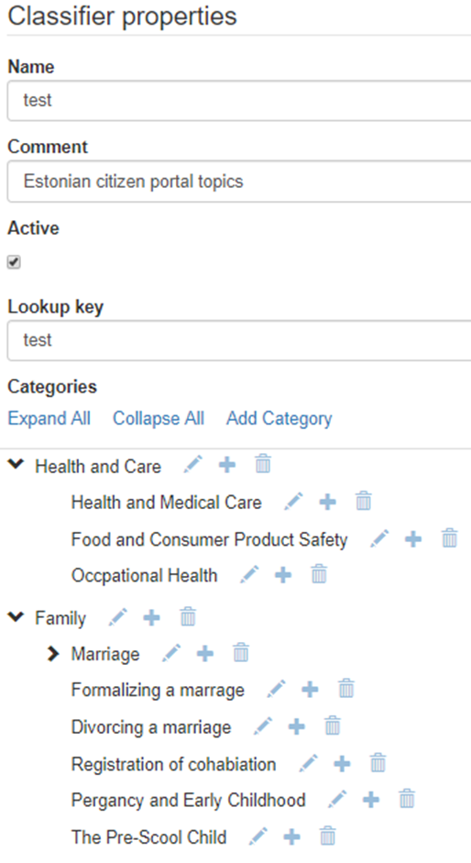

Dublin Core: https://www.dublincore.org/
Data Catalog Vocabulary (DCAT) https://www.w3.org/TR/vocab-dcat-3/
DCAT Application Profile for data portals in Europe: https://interoperable-europe.ec.europa.eu/collection/semic-support-centre/solution/dcat-application-profile-data-portals-europe/release/300

